NAME: K. Manoj Kumar
REGISTER NUMBER: 23MIS0159
COURSE NAME: Agile Development Process and DevOps Lab
COURSE CODE: ISWE406P
SLOT: L51+L52

TASK 1: Jenkins Familiarization Objective:
Understand Jenkins UI and basic navigation
Tasks:
1. Open Jenkins Dashboard in browser
2. Identify:
o Dashboard
o Manage Jenkins
o New Item
o Build History
3. Check Jenkins version
Expected Output:
Screenshot or note of Jenkins version
DASHBOARD, Jenkins Version:
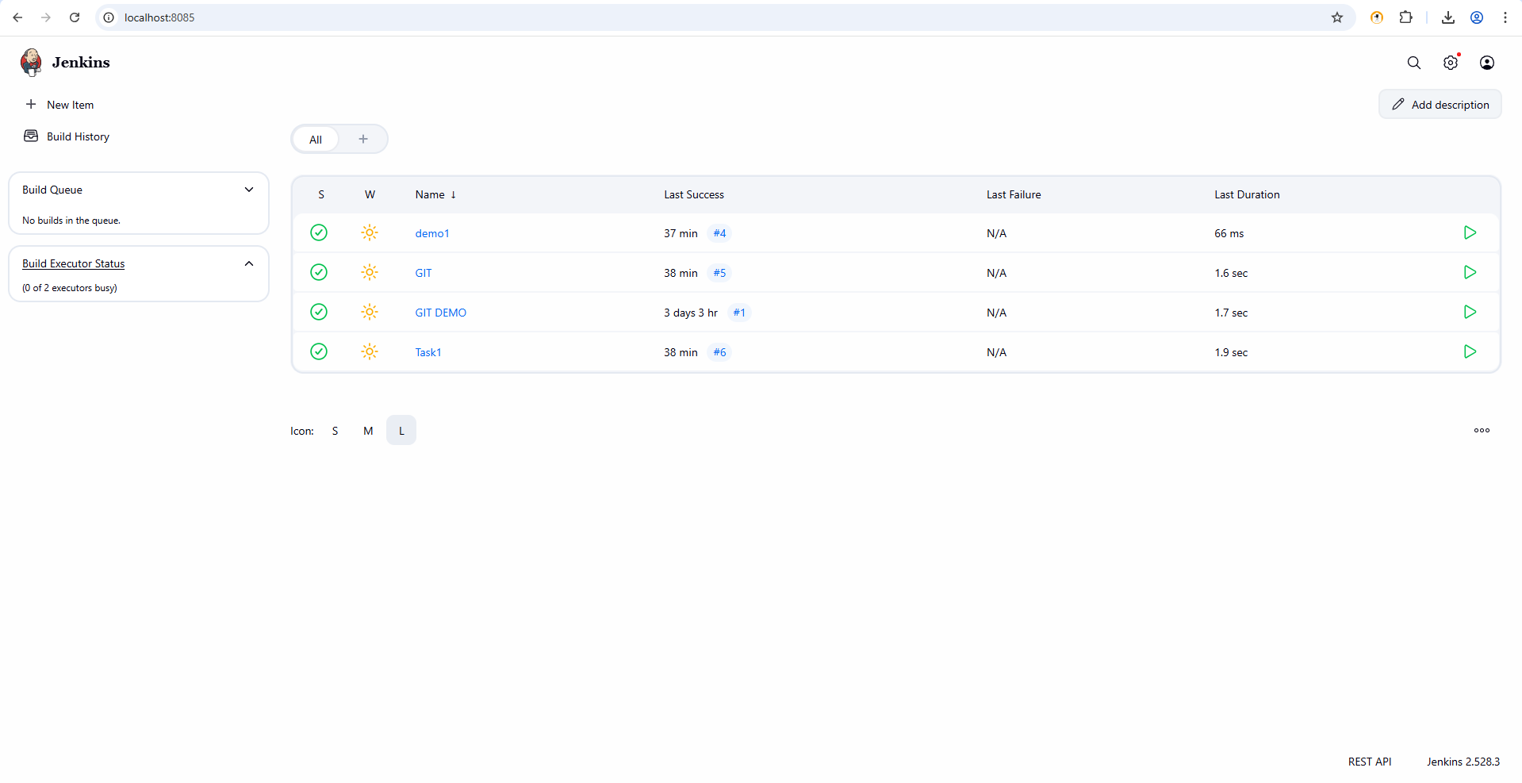

NEWITEMS:
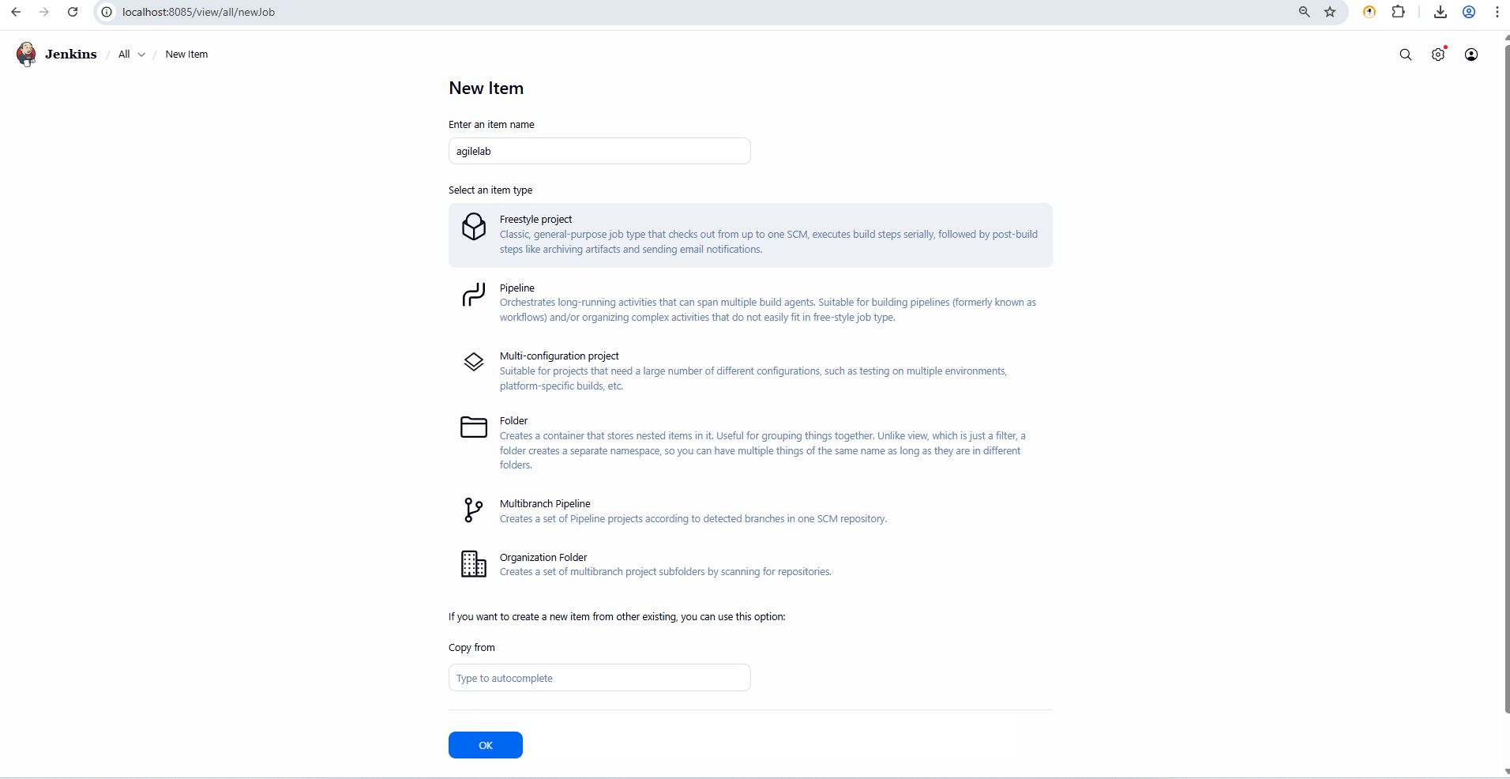
Build History:
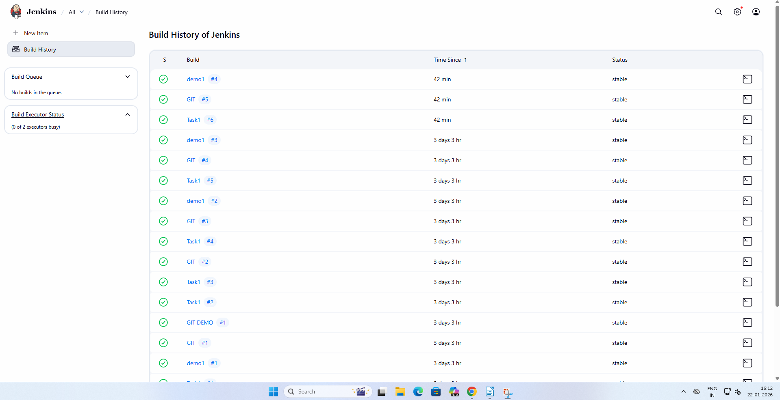
MANAGE JENKINS:
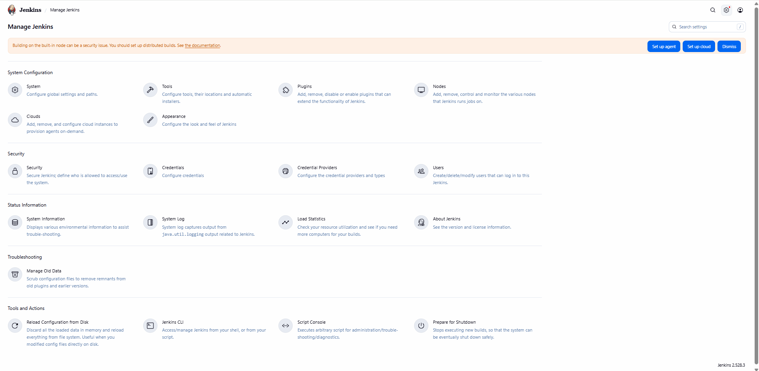
TASK 2: Create First Freestyle Job
Objective:
Create and run a Jenkins job
Tasks:
- Create a Freestyle project named Hello-Jenkins
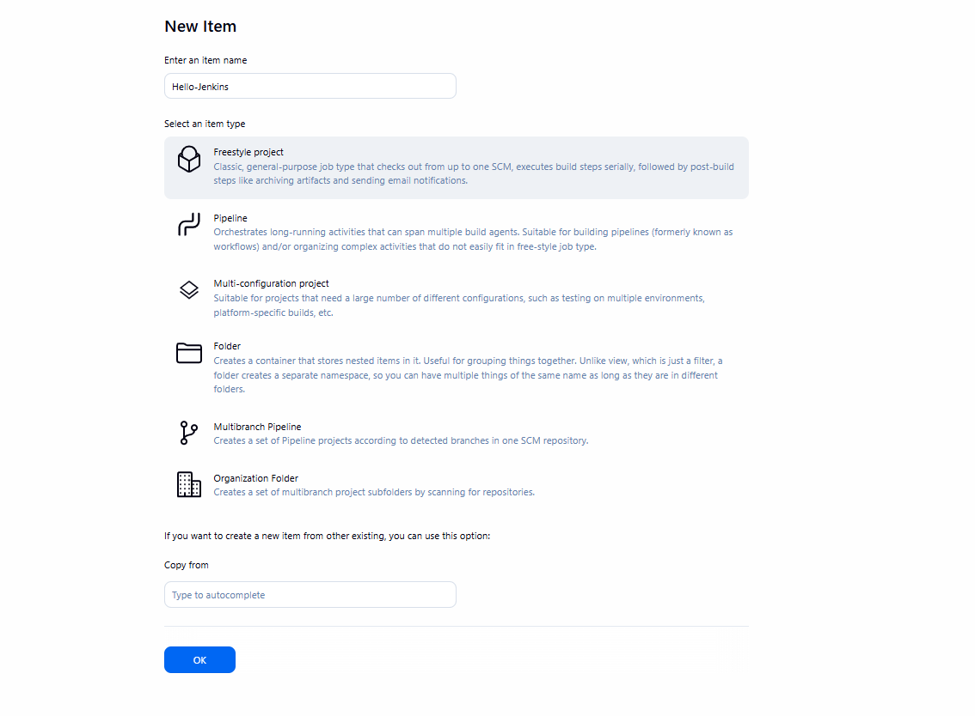
2. Add a description
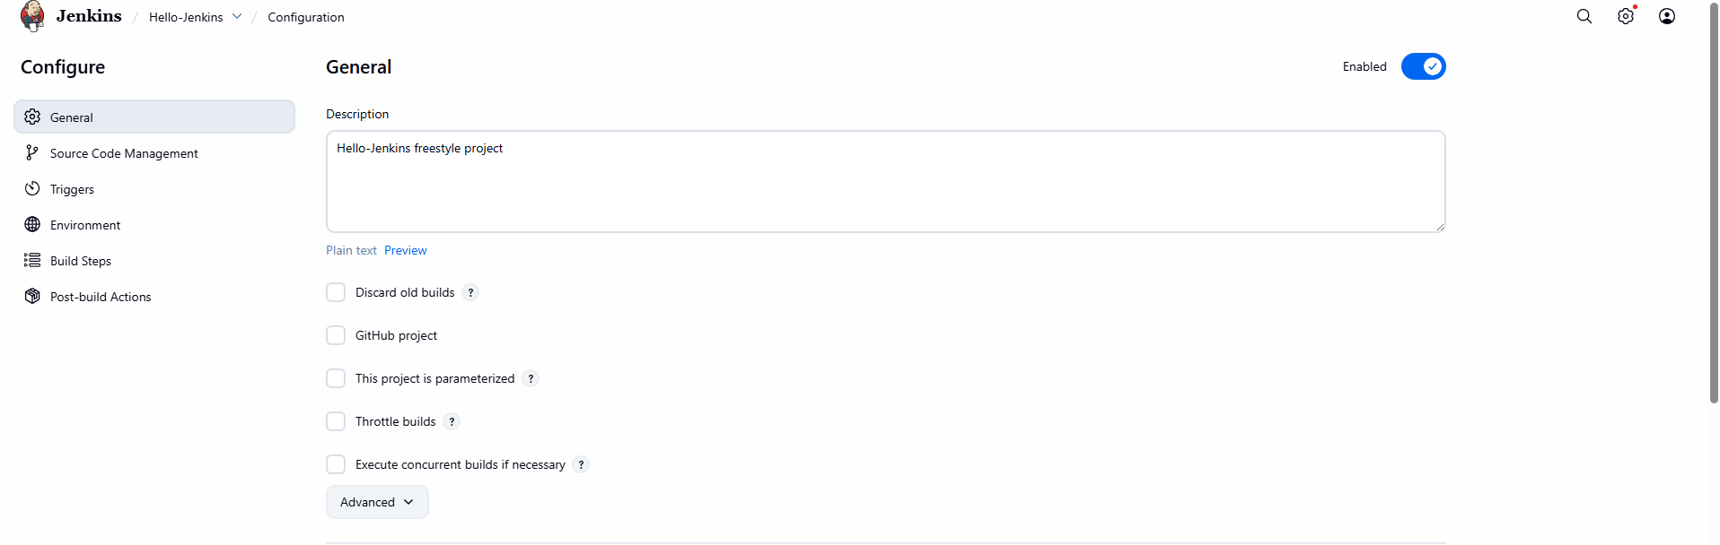

3. Add build step: o Execute shell / Windows batch command o Print "Hello Jenkins"
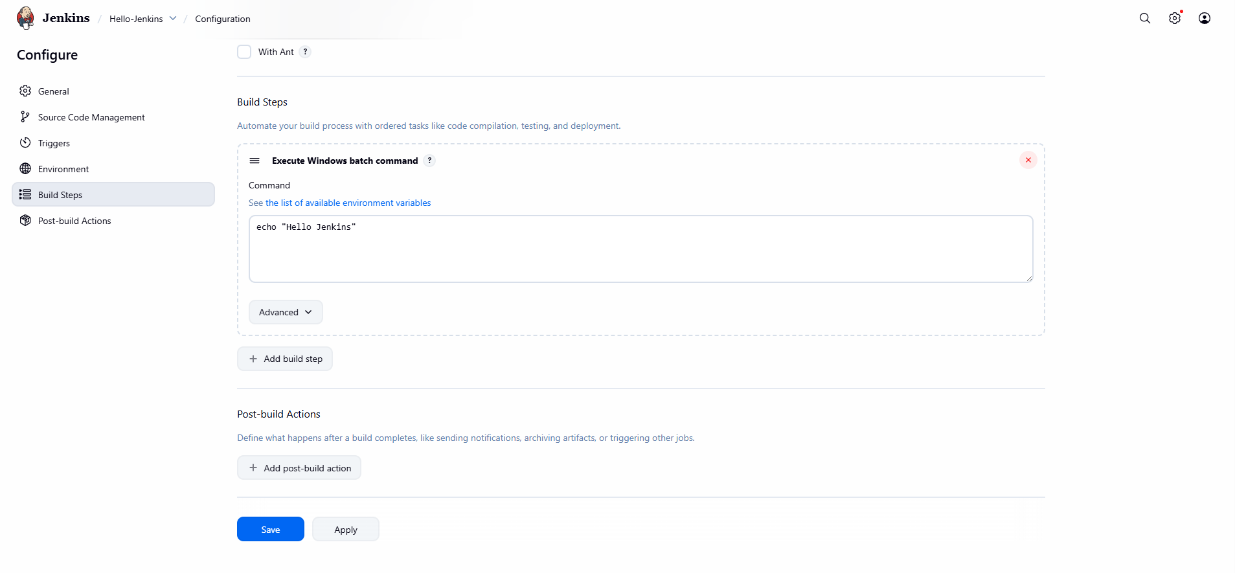
4. Build the job manually
Expected Output: Console output showing message
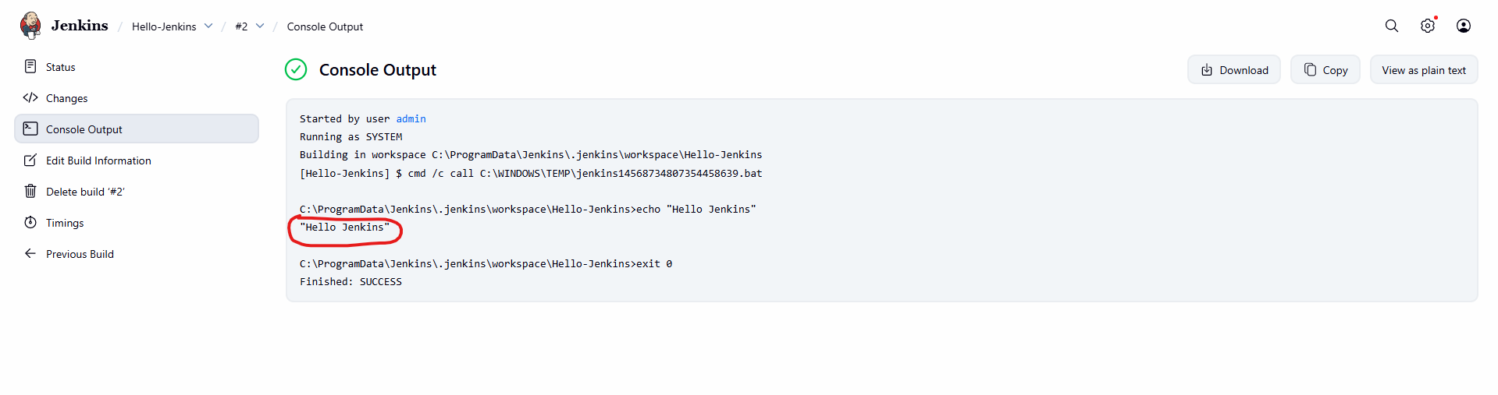

TASK 3: Jenkins Workspace & Commands
Objective: Understand workspace usage
Tasks:
- Navigate to job workspace
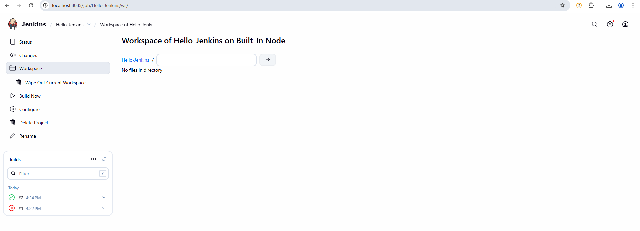
2. Create a text file using build step
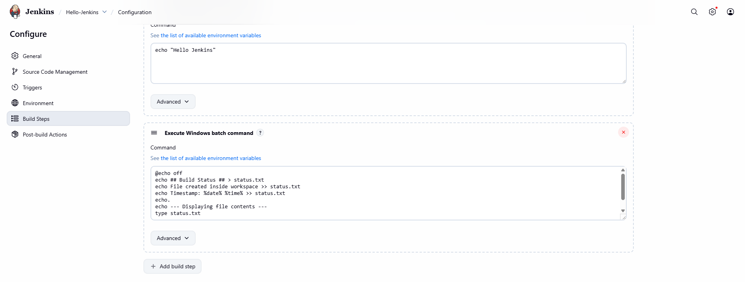
3. Display file contents in console
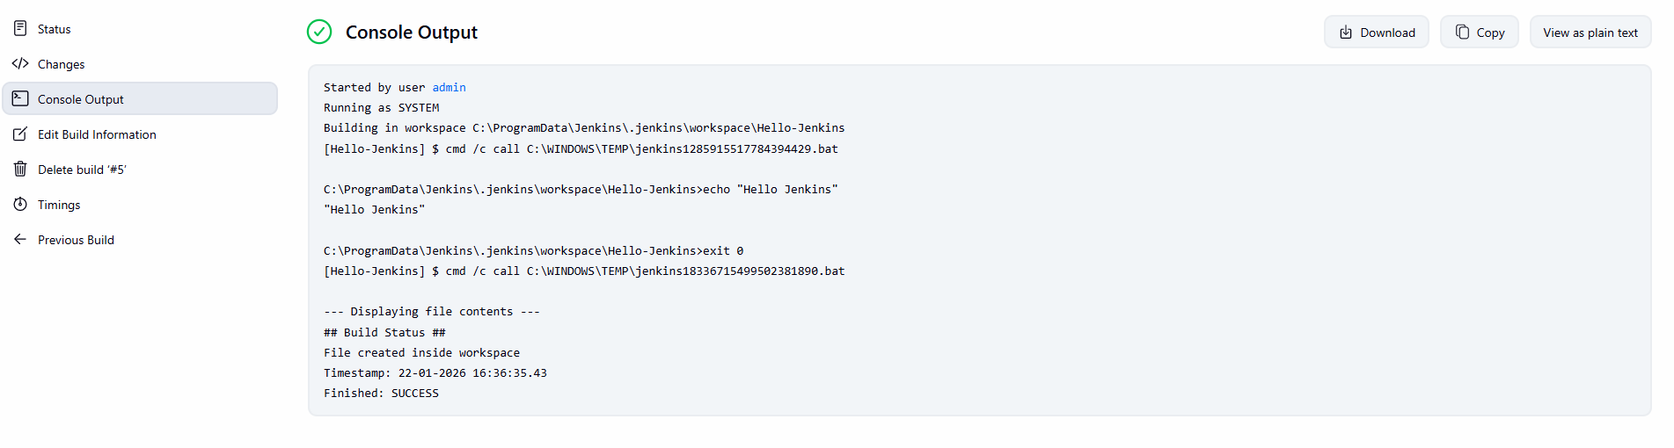
Expected Output: File created inside workspace
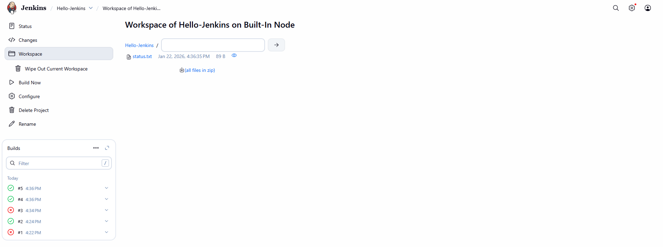
TASK 4: Git Integration
Objective: Integrate Jenkins with GitHub
Tasks: 1. Create a GitHub repository with sample code
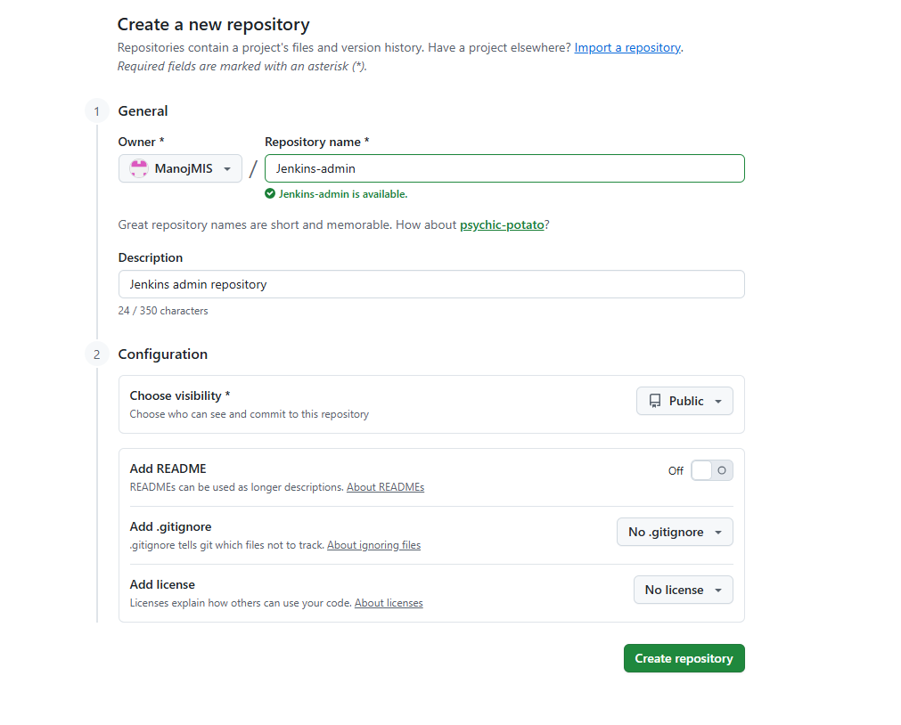

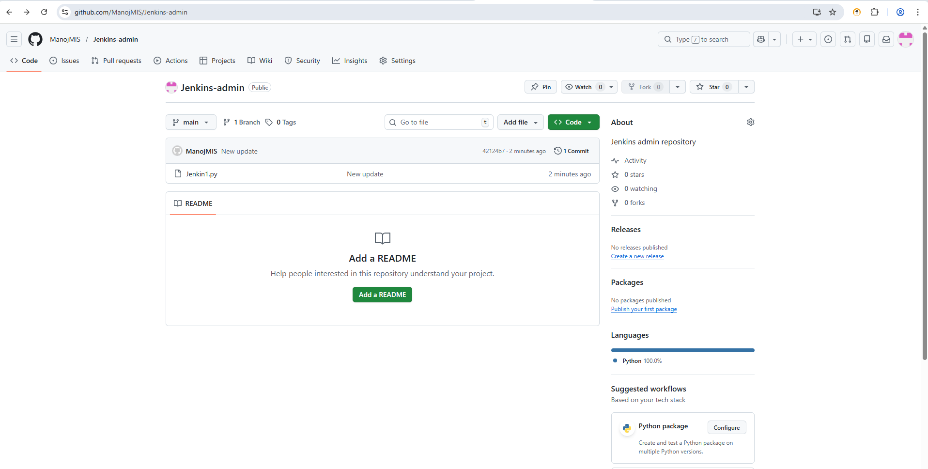
2. Configure Git in Jenkins
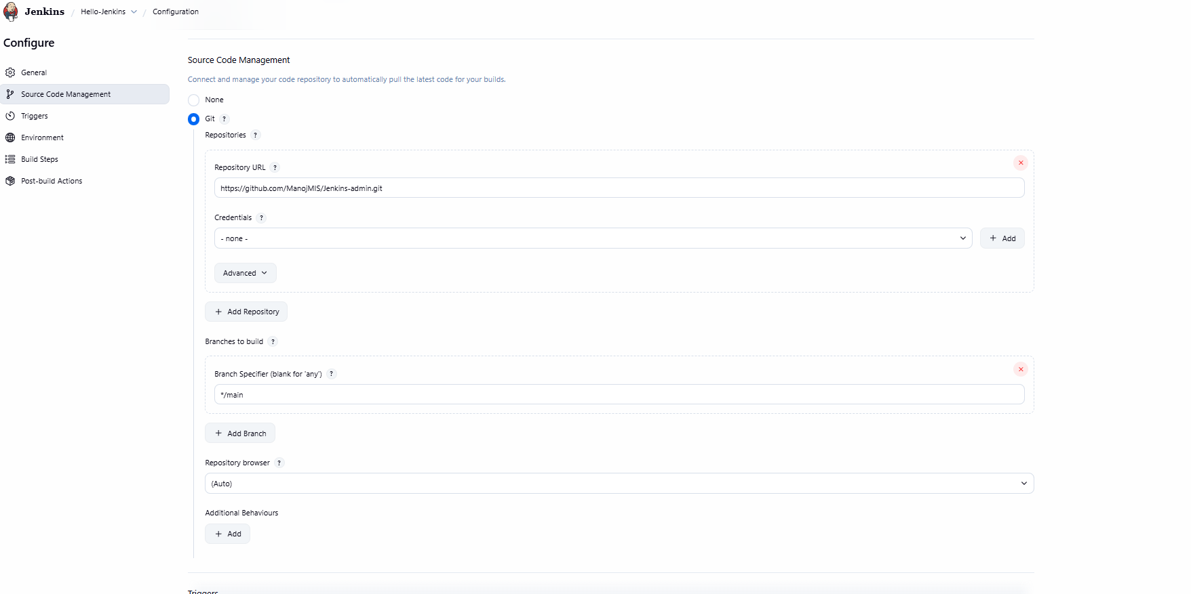
3. Add Git repository URL in job
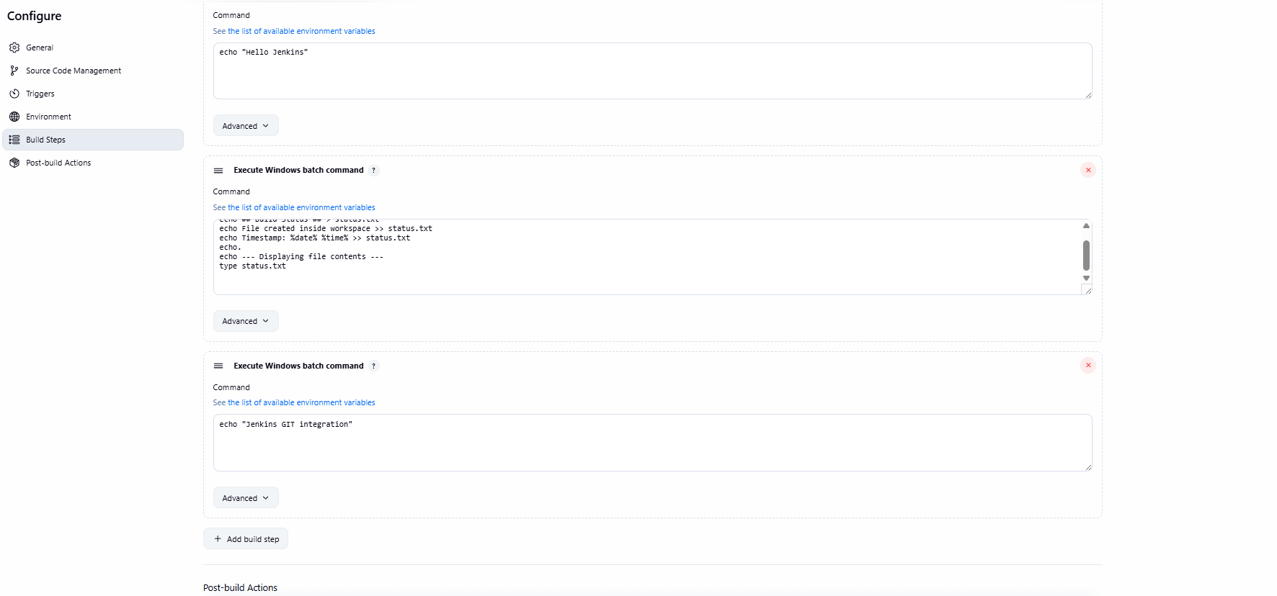
4. Build and verify code checkout
Expected Output: Source code visible in workspace
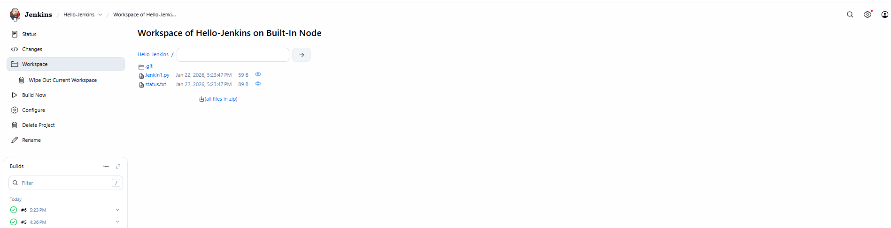

TASK 5: Poll SCM Trigger
Objective: Automatically trigger builds on code change
Tasks: 1. Enable Poll SCM
2. Set schedule: * * * * *
3. Modify GitHub file and commit
4. Observe automatic build Expected Output: • Build triggered without manual action
TASK 6: Parameterized Build
Objective: Use parameters in Jenkins job
Tasks: 1. Enable parameterized build
2. Add String parameter USERNAME
3. Print parameter value in build step Expected Output: • Console output showing parameter value

TASK 7: Java Build Using Jenkins
Objective: Compile Java program using Jenkins
Tasks: 1. Create simple Hello.java
2. Compile using javac
3. Run Java program Expected Output: • Java output in console

TASK 8: Archive Artifacts
Objective: Store build outputs
Tasks: 1. Generate .class or .jar file
2. Archive artifacts in post-build action
3. Download artifact from Jenkins UI Expected Output: • Artifact available for download
TASK 9: Users & Roles
Objective: Manage Jenkins users
Tasks: 1. Create two users
2. Assign read-only permission to one user
3. Assign build permission to another user Expected Output: • Permission differences verified
TASK 10: Simple Jenkins Pipeline
Objective: Create basic pipeline
Tasks: 1. Create Pipeline job
2. Write pipeline with stages: o Checkout o Build o Test
3. Run pipeline Expected Output: • Pipeline stage view

TASK 11: Jenkinsfile from Git
Objective: Pipeline as Code
Tasks: 1. Create Jenkinsfile in Git repo
2. Configure pipeline from SCM
3. Trigger build Expected Output: • Pipeline executed from Git

TASK 12: Post-Build Actions
Objective: Handle build result
Tasks: 1. Add post section
- Print message on success/failure Expected Output: • Appropriate message displayed
TASK 13: Trigger Job from Another Job
Objective: Job chaining
Tasks: 1. Create Job-A and Job-B
- Configure Job-B to trigger after Job-A Expected Output: • Job-B triggered automatically
TASK 14: Workspace Cleanup
Objective: Manage disk usage
Tasks: 1. Install Workspace Cleanup plugin
- Clean workspace before build Expected Output: • Workspace cleared before execution TASK
15: Mini CI Project
Objective: Implement basic CI flow
Tasks: 1. Git commit → Jenkins build
2. Compile code
3. Archive artifacts
4. Fail build on error Expected Output: • Automated CI pipeline

TOOL:GIT ACTIONS
1.)GIT ACTIONS DASBOARD:
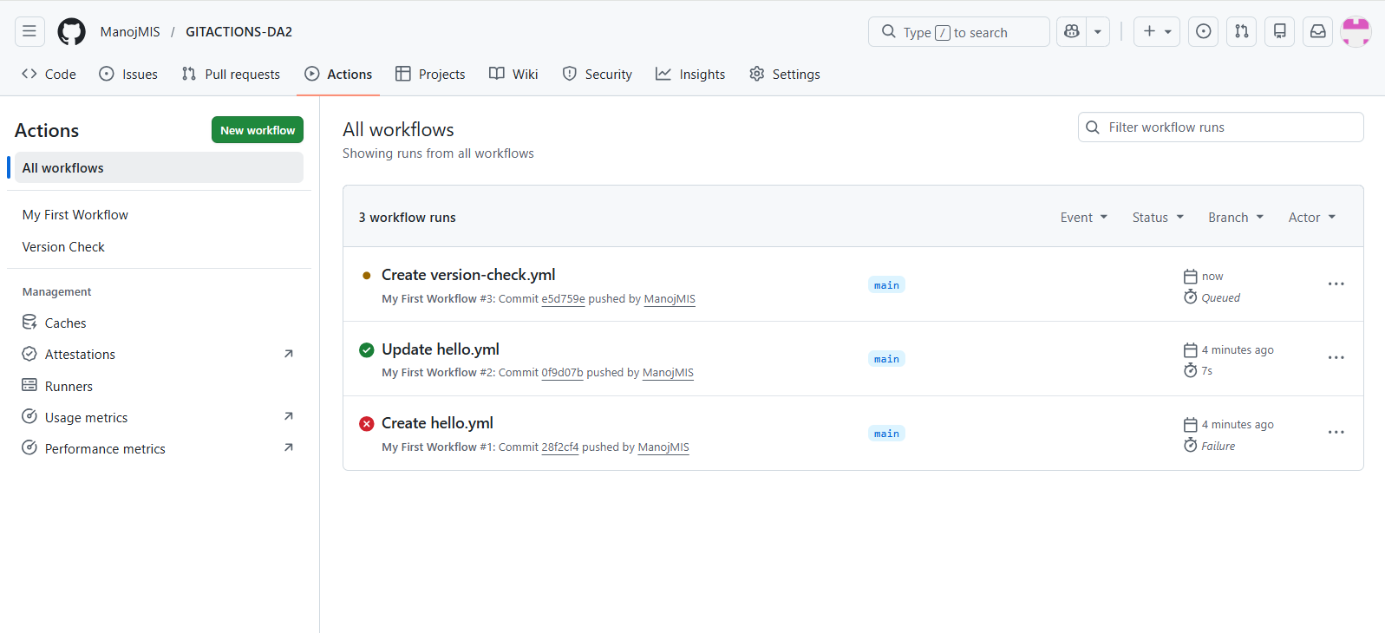
VERSION AND OUTPUT:
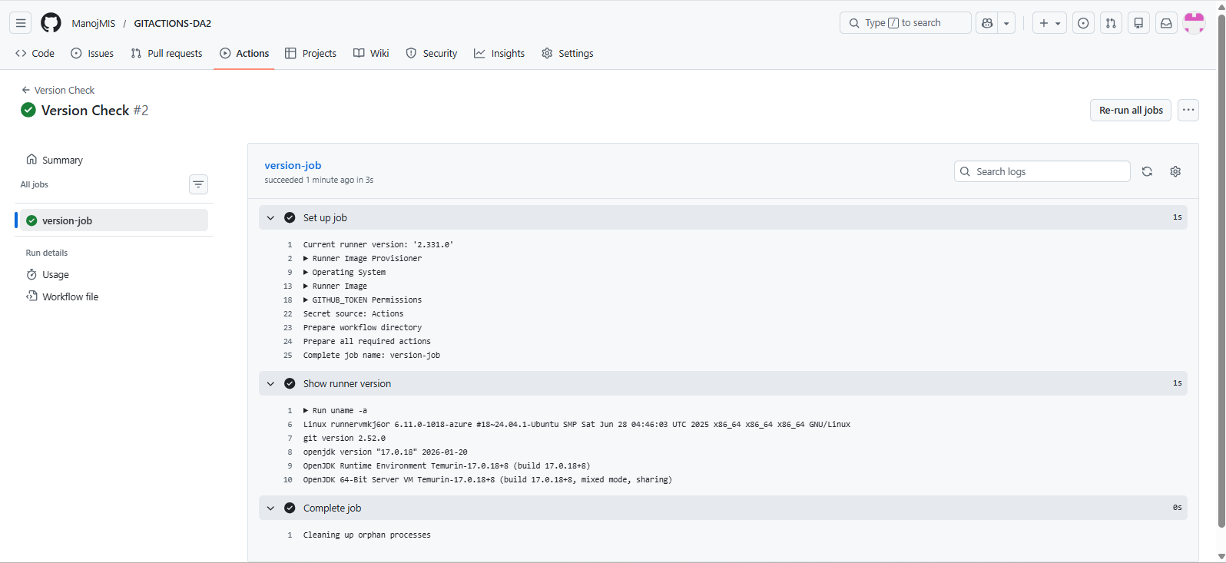

2.)First Freestyle job created and Output:
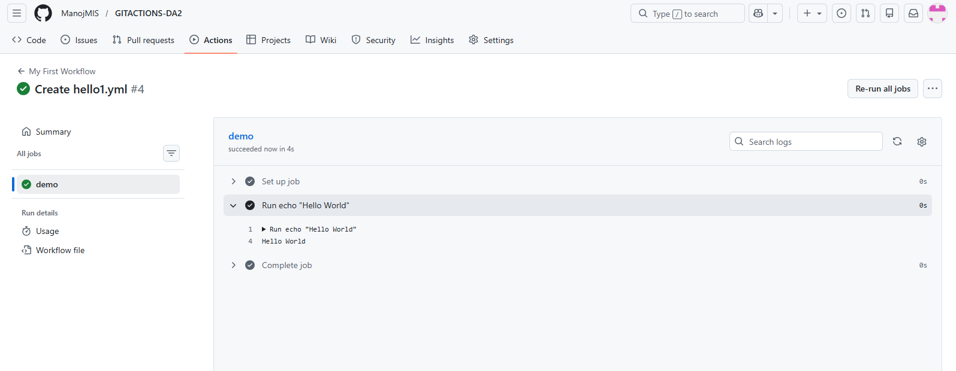
3.)Text File Created:
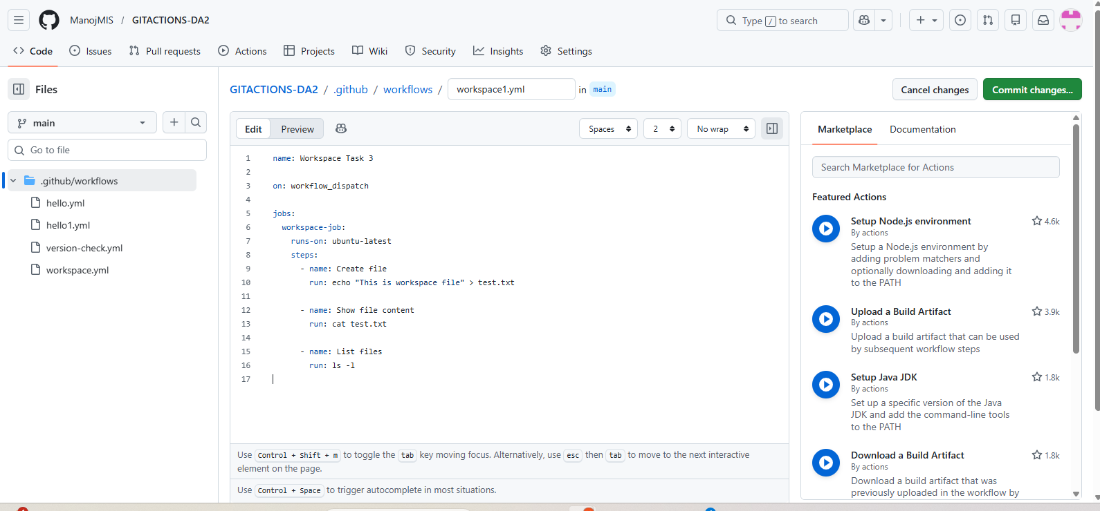

Job Workspace:
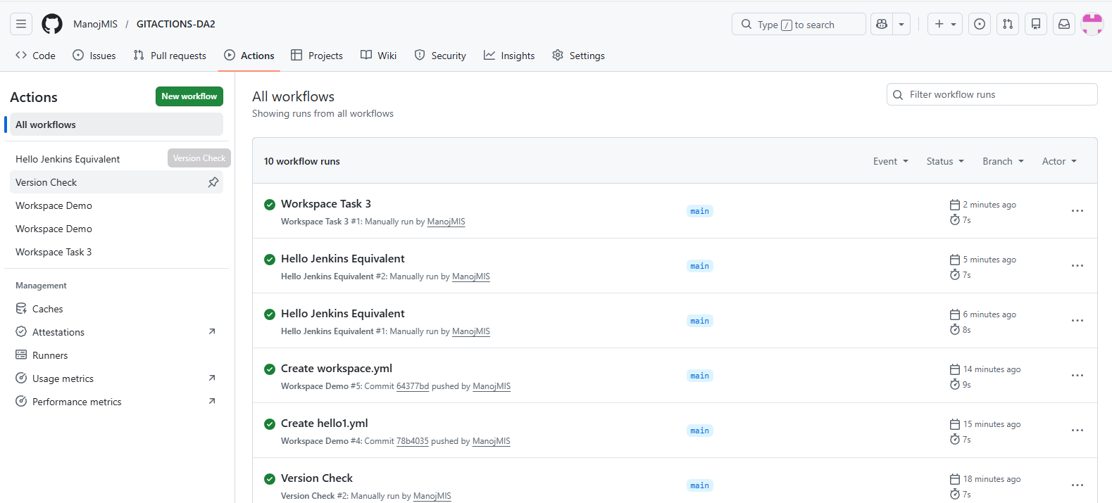
OUTPUT:
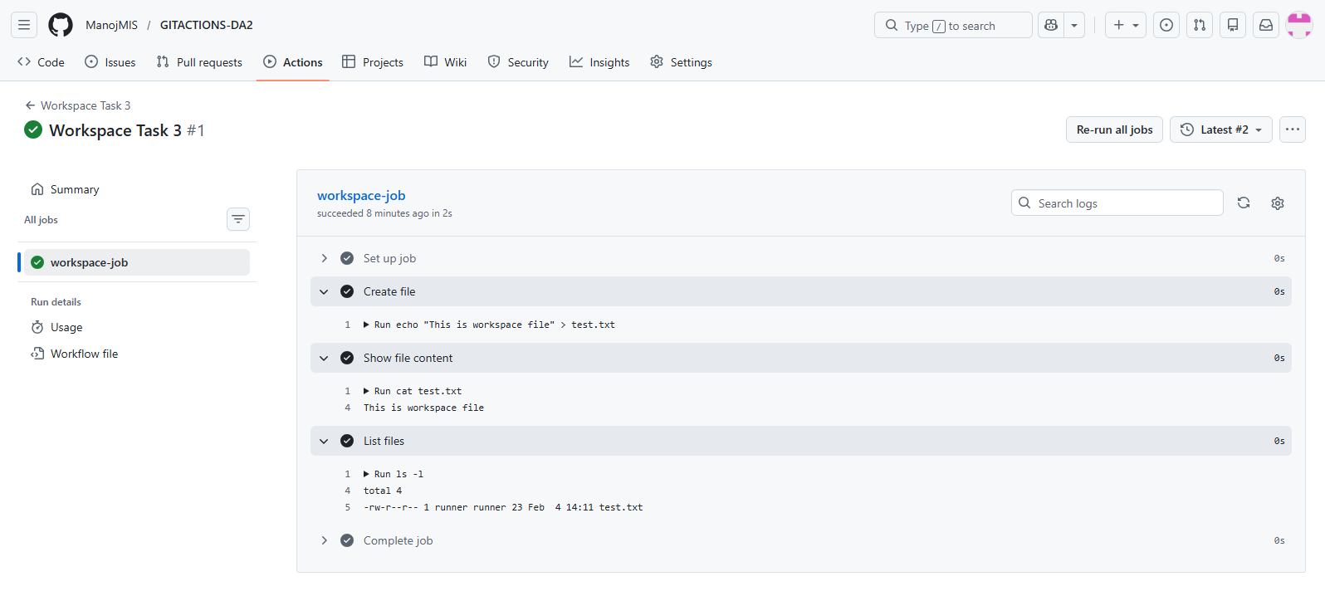
4.)Git Integration Workflow created:
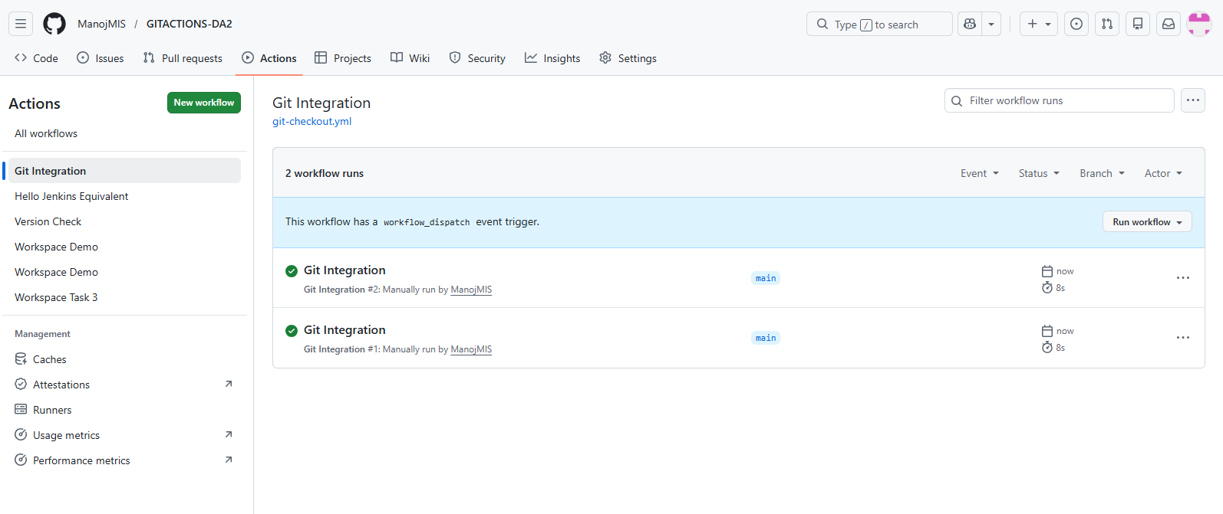
OUTPUT:
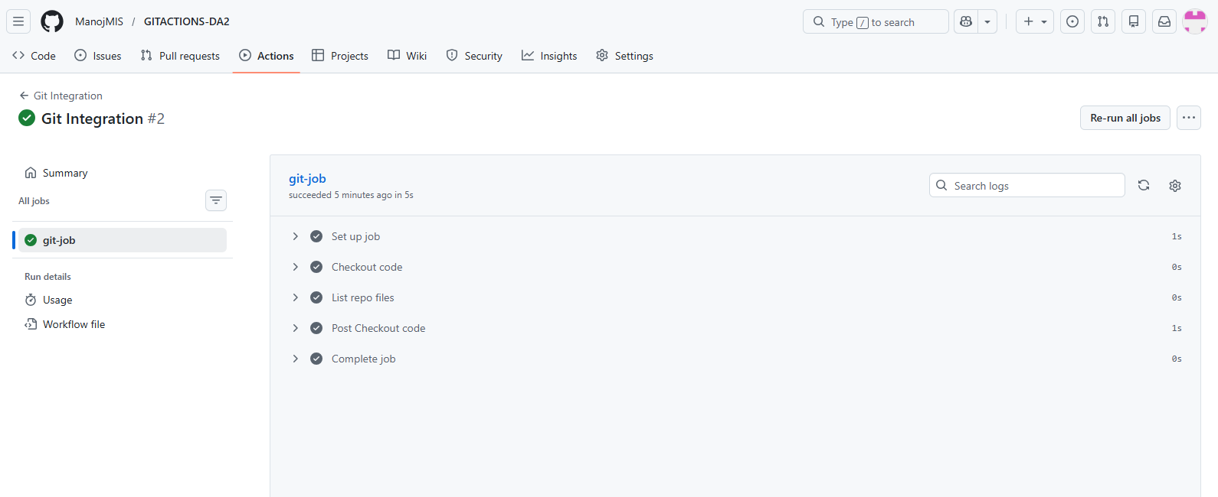
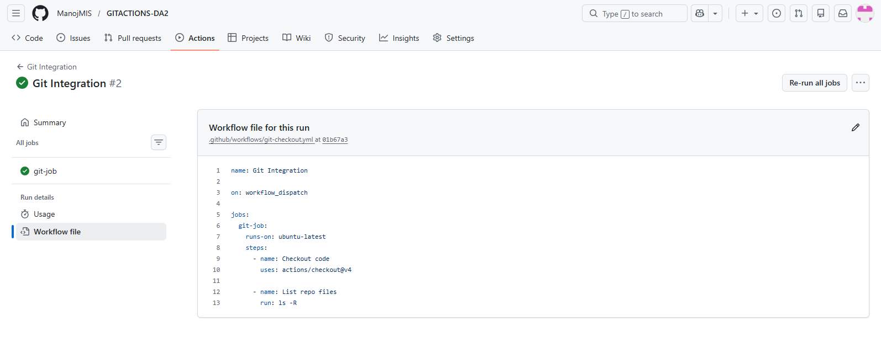
5.)Auto Trigger Workflow created:
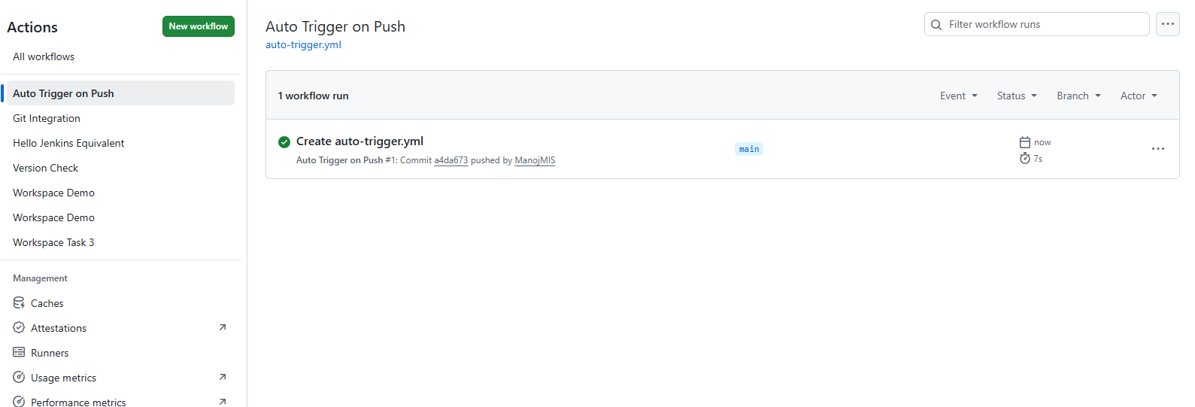

OUTPUT:
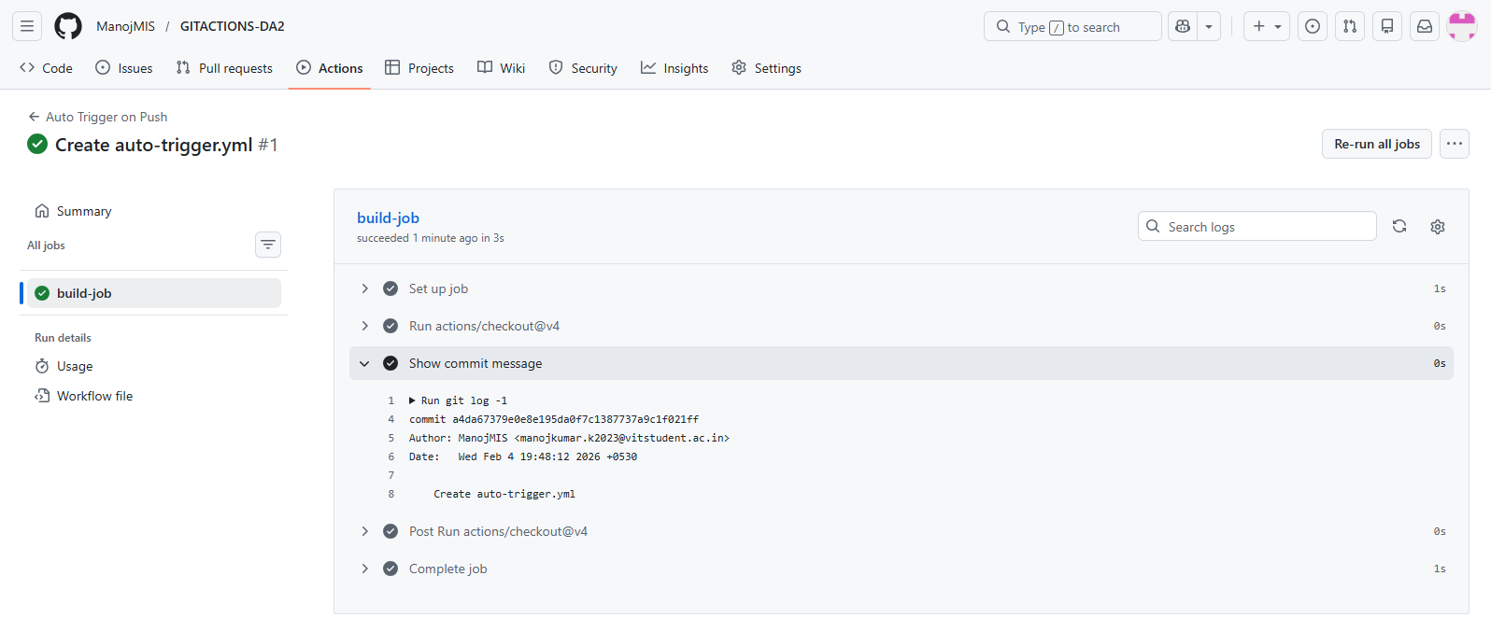
6.)Parameterized Workflow Created:
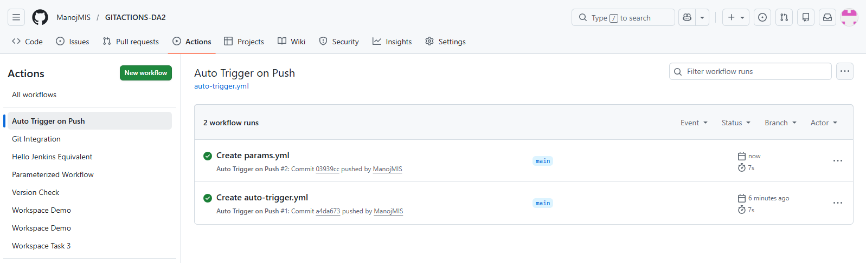
OUTPUT:
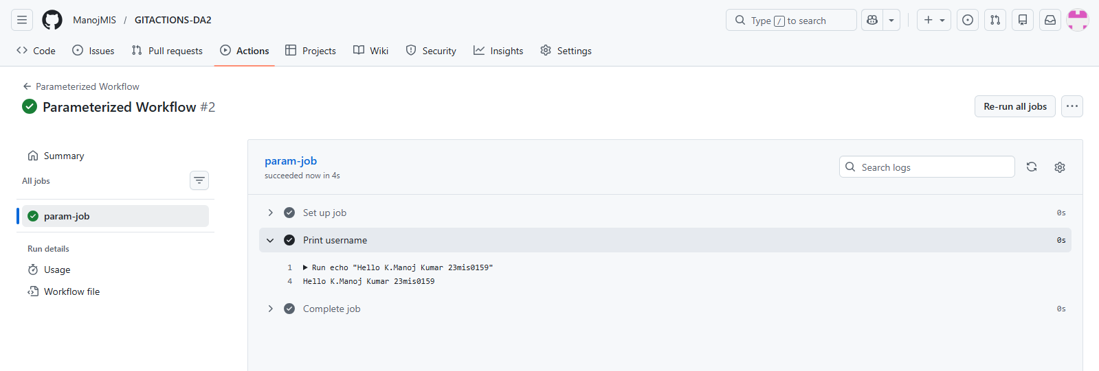

7.)Hello.java FILE:
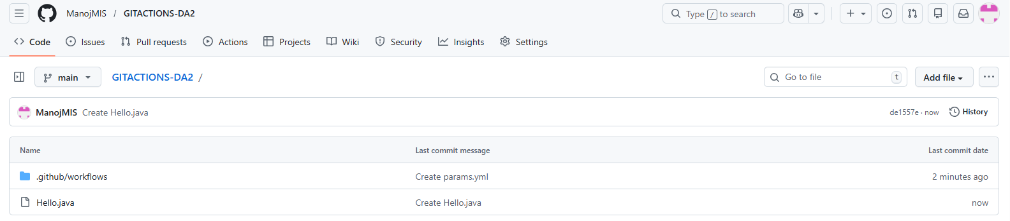
JAVA workflow created:
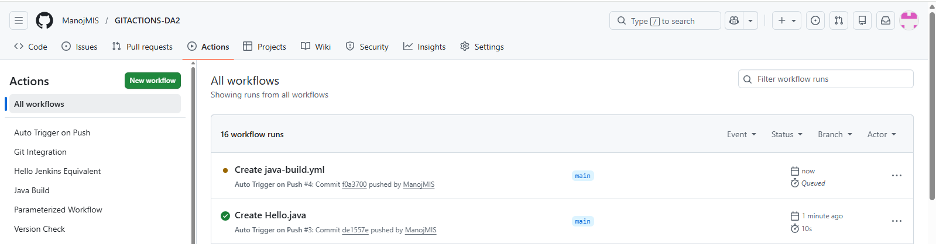
OUTPUT:
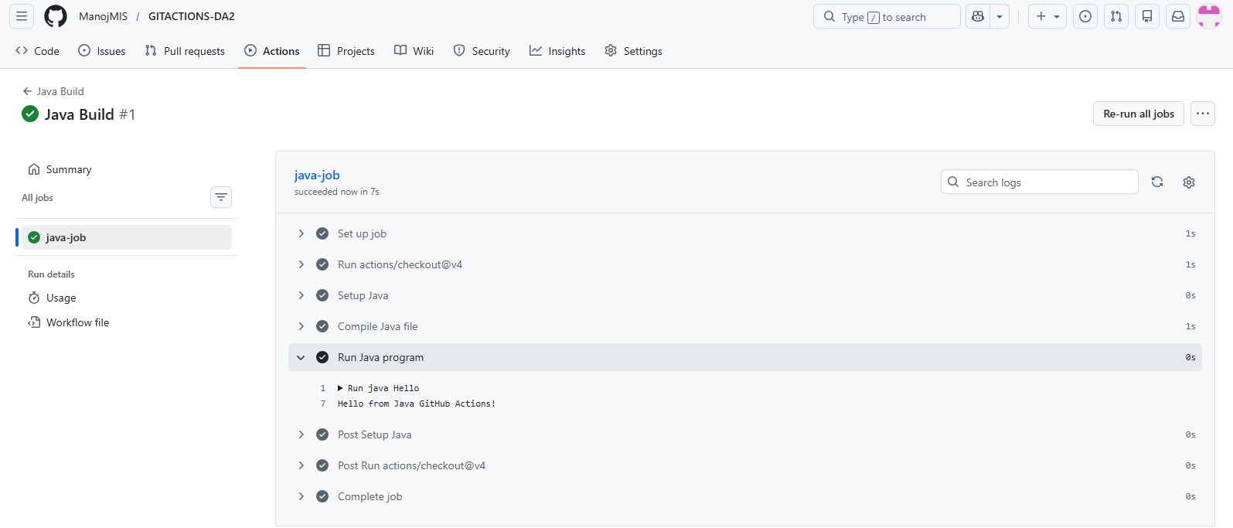

8.)Artifacts workflow Created:
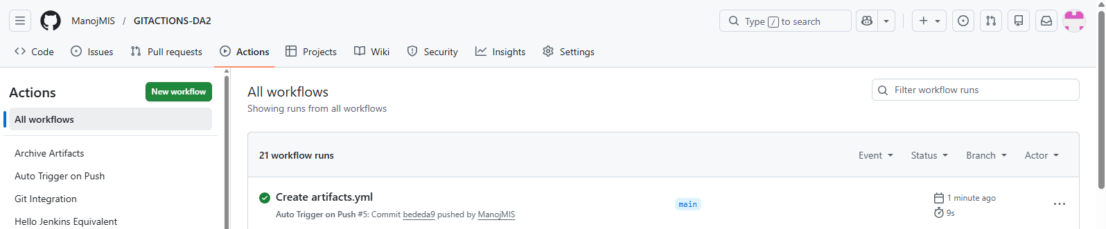
OUTPUT:
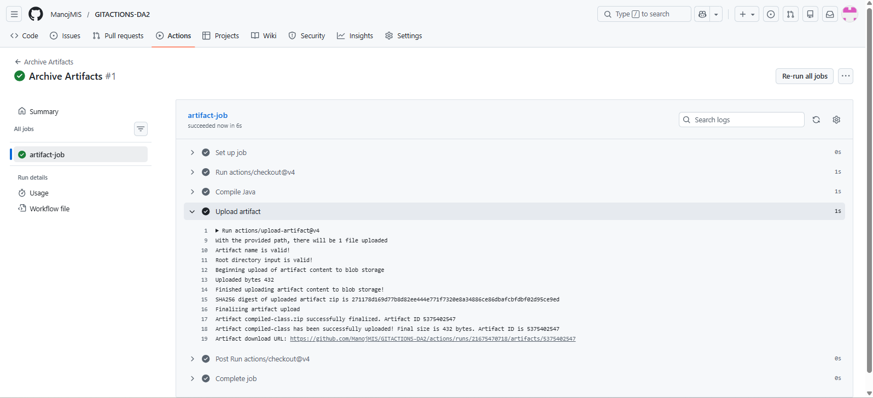
10.)
Pipeline workflow created:
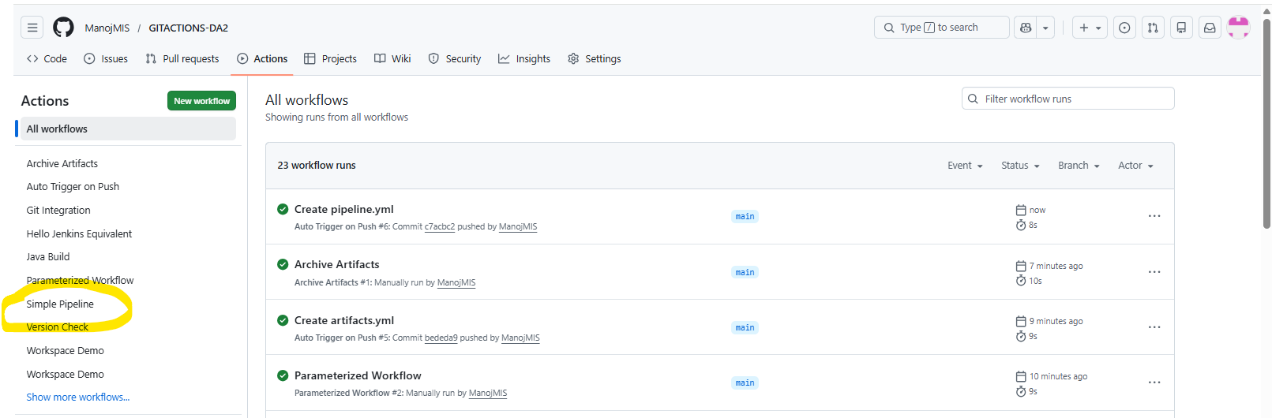

OUTPUT:
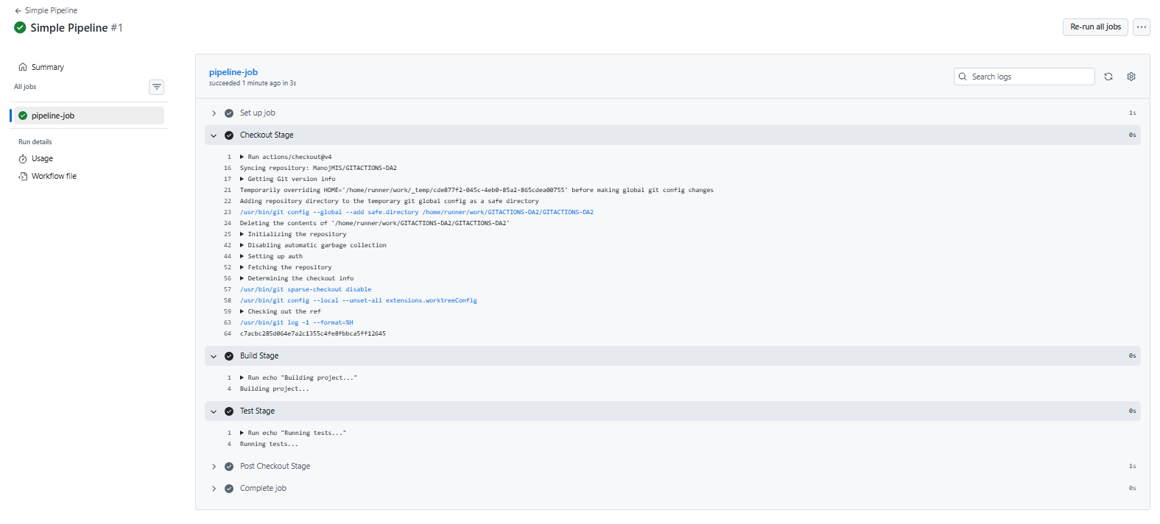
11.)
Pipeline from GIT workflow created:
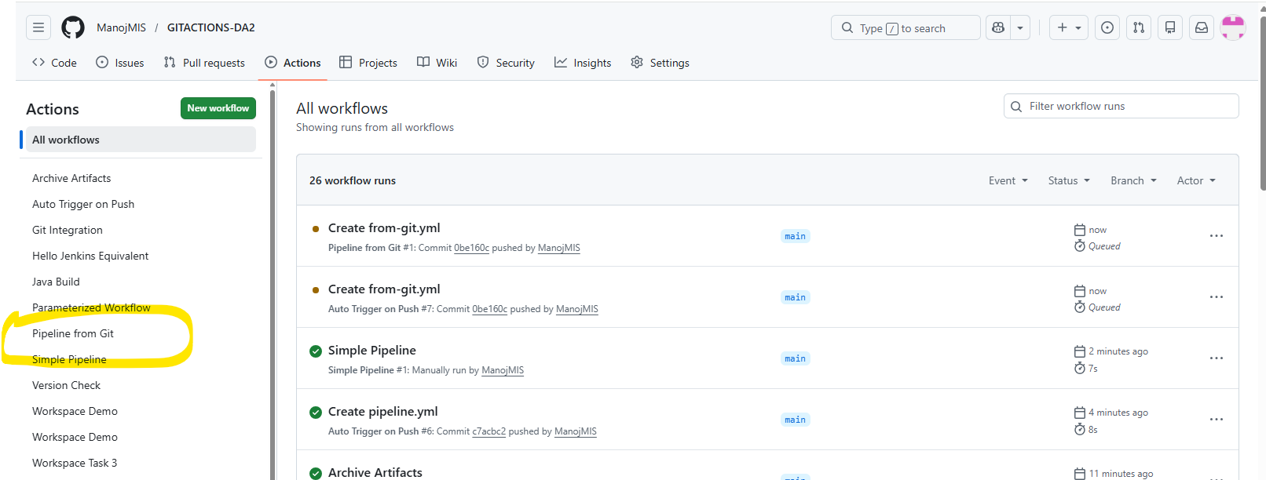

OUTPUT:
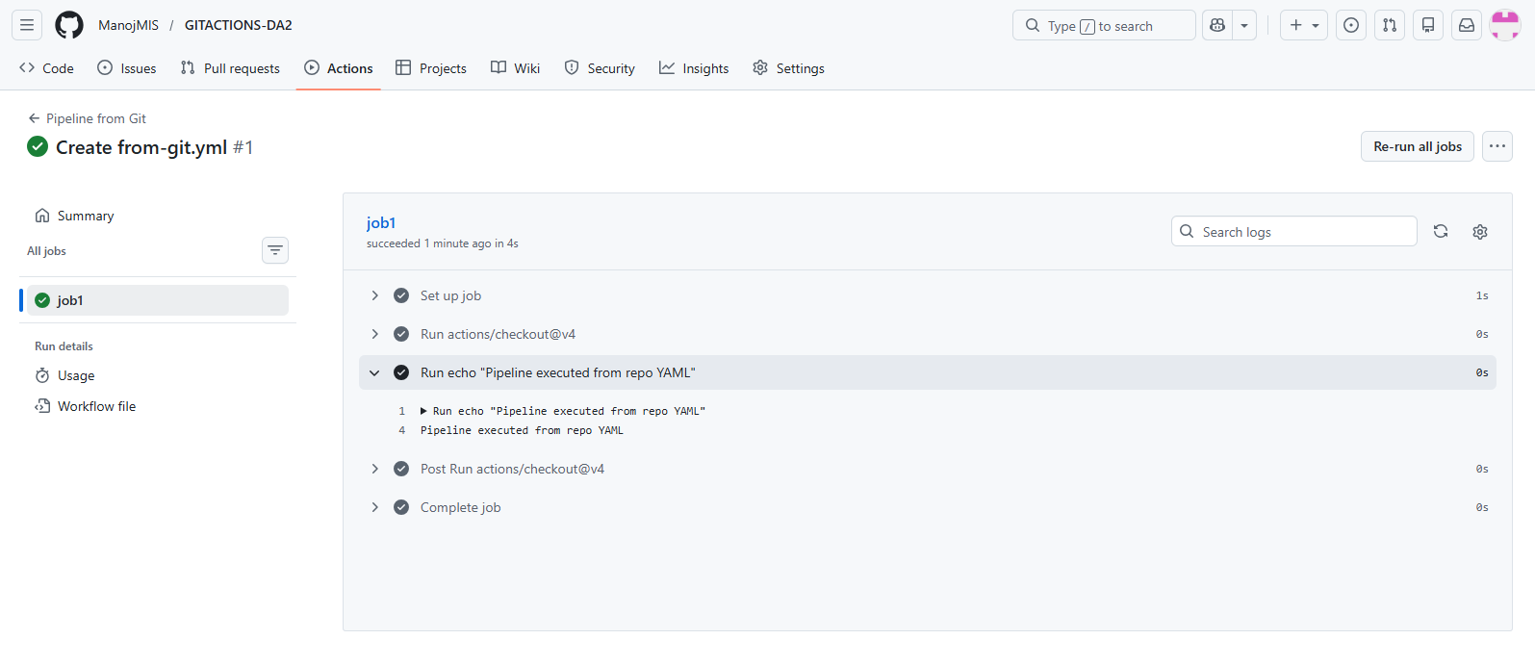
12.)
Post-build workflow created:
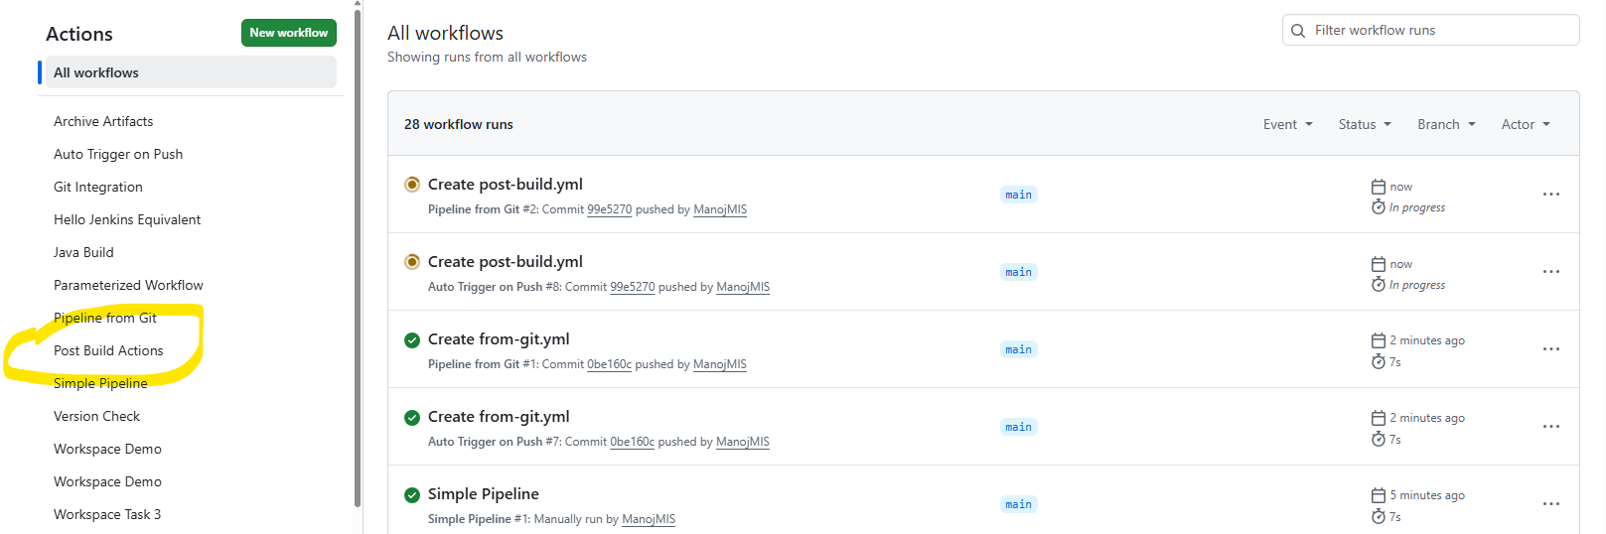
OUTPUT:
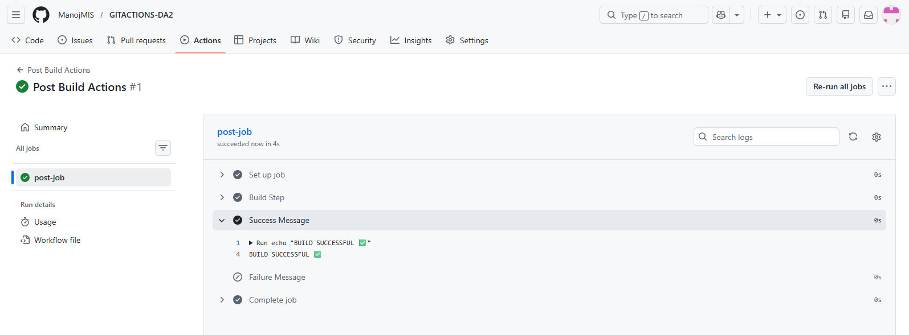
13.)
Chaining workflow created:
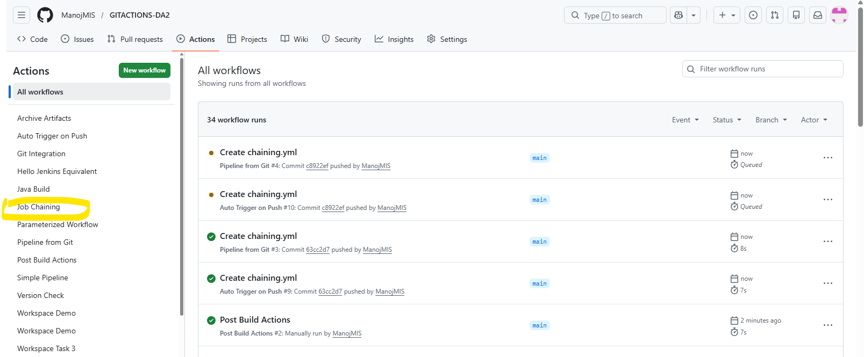
OUTPUT:
JOB-A:
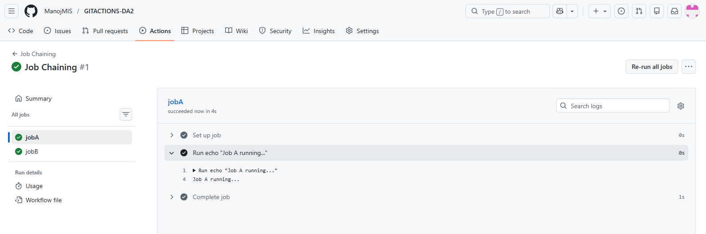
JOB-B:
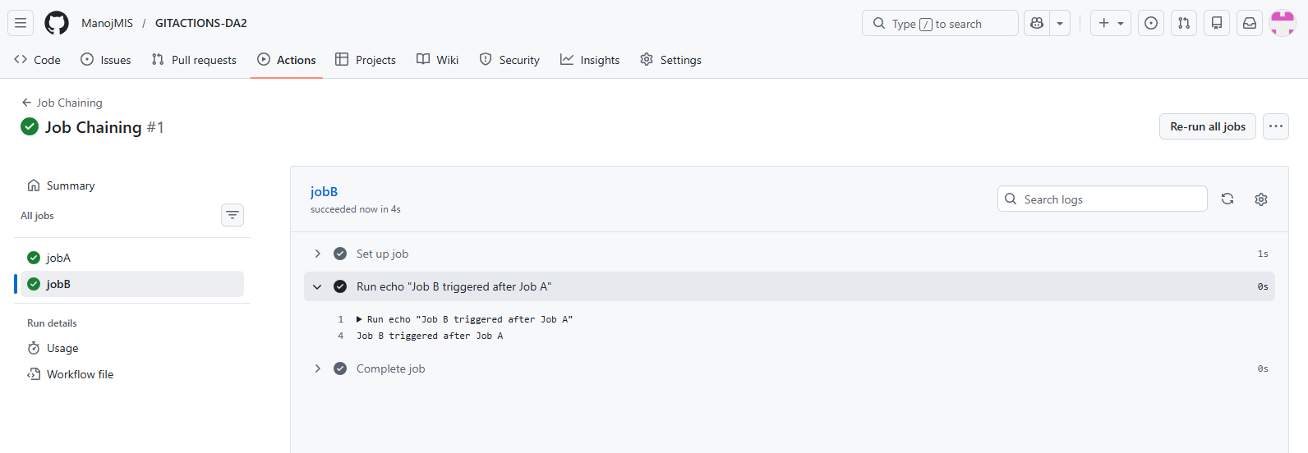
14.)
Cleanup Workflow created:
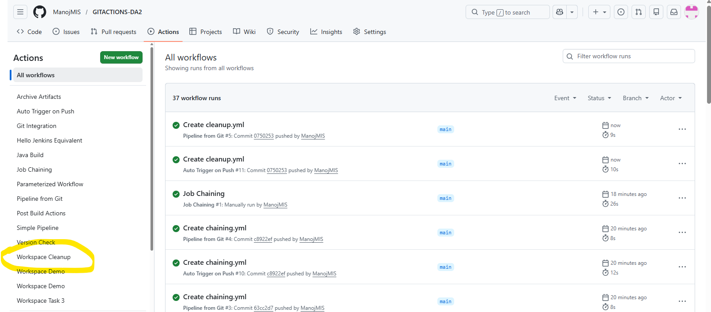
OUTPUT:
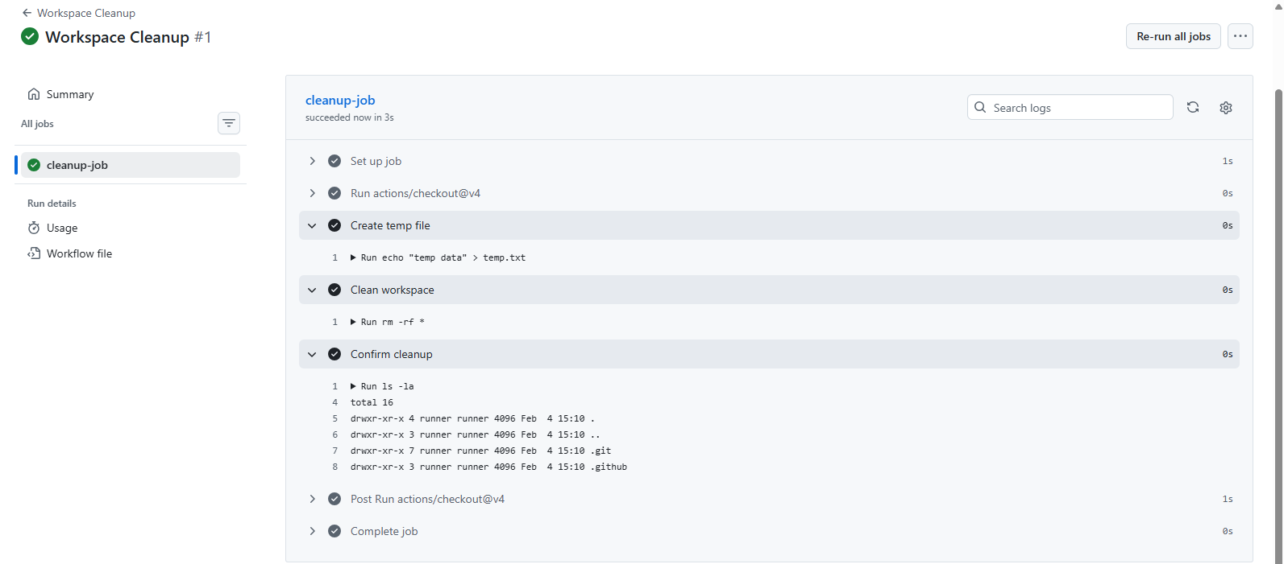

15.)
CI workflow created:
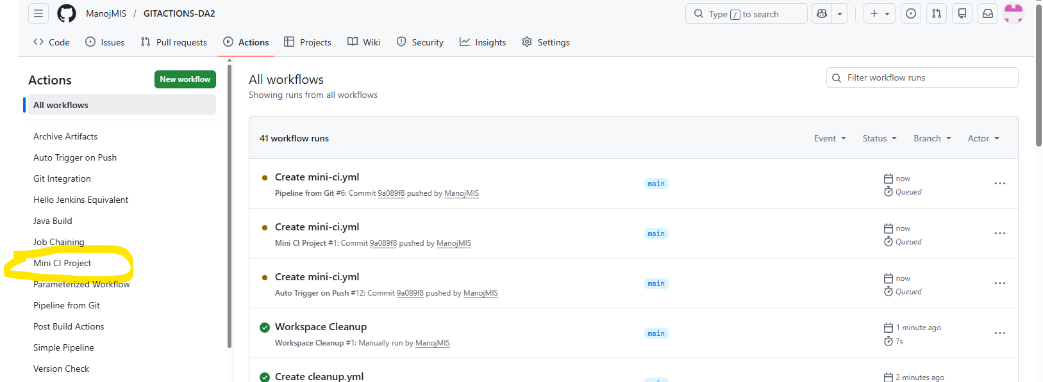
OUTPUT:
